2026 SCHEDULE of EVENTS

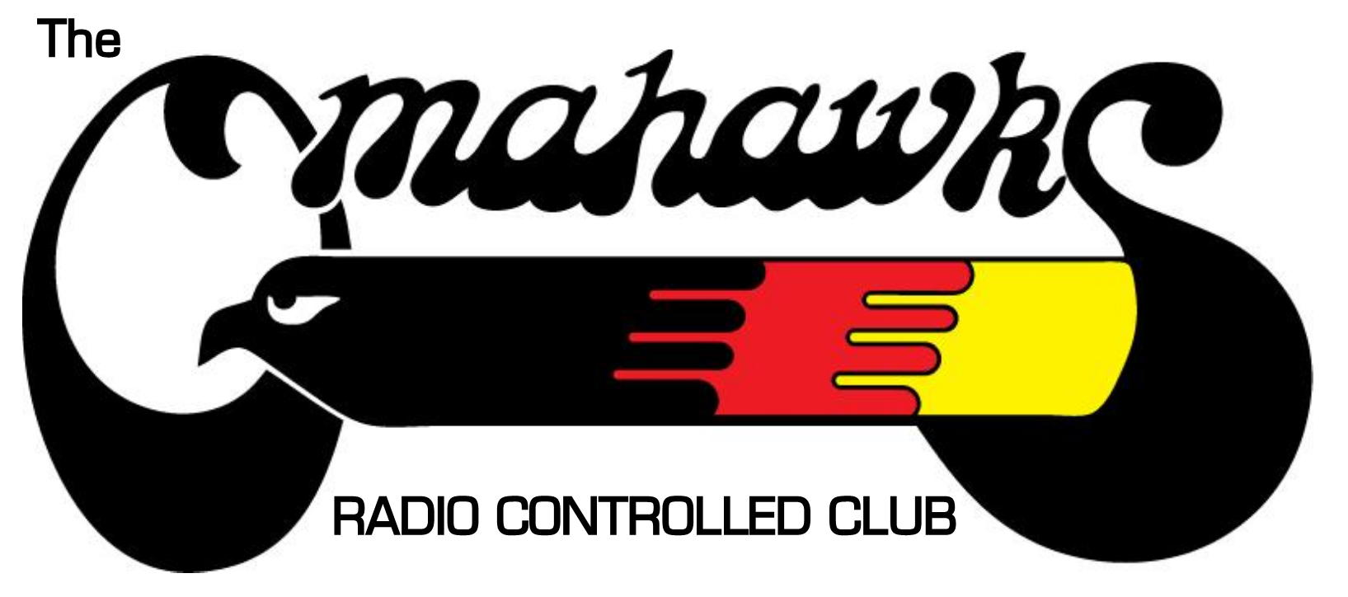Schedule Key:
Future club events in Black/Bold
Events Open to All AMA
Food Events
Float Fly
Occurred/past dates in Gray
Meeting occurrences are italicized
Outside of club events in orange
* Asterisk indicates an unusual date (due to to holiday/reschedule)

January 2026:
01.01 - 9:00 am - 11:30 am - New Year’s Day - First Flights & Hy-Vee Brunch/Coffee … was fantastic!
01.20 - 7:00 pm - Board Meeting [Google Meet]
01.30 - 7:00 - 8:30 pm - Member’s Meeting [Oakview ABLE ACE]
February:
02.14 - 11:00 - 3:00 - Aviation STEM Day [Oak View Mall/ABLE ACE]
02.17 - 7:00 - 8:00 pm - Board Meeting [Google Meet]
02.21 - 10:00 am - 3:00 pm - Lincoln Sky Knights Auction (Waverly)
02.27 - 7:00 - 8:30 pm - Member’s Meeting [Oakview ABLE ACE]
March:
03.17 - 7:00 - 8:00 pm - Board Meeting [Google Meet]
03.27 - 7:00 - 8:00 pm -Member Meeting [Oakview ABLE ACE]
03.28 - 9:00 - Noon - Hawk Field Spring Clean up [Weather Dependent]
03.29 - 5:00 pm - Training Night Kick Off Meeting [Villagio]
April:
04.02 - 6:00 pm - Training Night/Soft Start - #1(Sunset 7:50 pm)
04.09 - 6:00 pm - Training Night/Soft Start #2 (Sunset 8:00 pm)
04.16 - 6:00 pm - Training Night/Soft Start #3 (Sunset 8:05 pm)
04.21 - 7:00 - 8:00 pm - Board Meeting [Google Meet]
04.23- 6:00 pm - Training Night/Soft Start #4 (Sunset 8:15 pm)
04.24 - 7:00 - 8:00 pm - Member’s Meeting [Oakview Mall]
04.30 - 6:00 pm - Training Night #5– (Sunset 8:20 pm)
May:
05.07 - 6:00 pm - Training Night #6 (Sunset 8:30 pm)
05.09 - 9:00 am - Noon - Old Timers, any slow flier (donuts, coffee, juice)
05.14 - 6:00 pm - Training Night #7 (Sunset 8:35 pm)
05.19 - 7:00 - 8:00 pm - Board Meeting [Google Meet]
05.21 - 6:00 pm - Training Night #8 (Sunset 8:40 pm)
05.23 - 6:00 pm - Drone Event (Don D.)

05.25 - 9:00 am - 11:00 - Traditional President’s Family Friendly Feast (‘Egg Burn’) Breakfast
05.28 - 6:00 pm - Training Night #9 (Sunset 8:50 pm)
05.29 - 7:00 - 8:00 pm - Member’s Meeting [ Hawk Field] - Dinner 6pm
05.30 - 9:00 am Any SIG plus what you brung fun fly
June:
06.03 - 8:30 - 11:30 pm - Electric Sailplanes
06.04 - 6:00 pm - Training Night #10 (Sunset 8:50 pm)
…. with 402 BBQ
06.06 - 8:30 am - 11:30 am - Float Fly - (Standing Bear Lake)
06.11 - 6:00 pm - Training Night #11 (Sunset 9:00 pm)
06.13 - 1:00 pm - EDF Jet Event
06.16 - 7:00 pm - Board Meeting [Google Meet]
06.18 - 6:00 pm - Training Night #12 (Sunset 9:00 pm)
06.20 - 1:00 pm - Combat Event –Lunch provided @ noon
06.25 - 6:00 pm - Training Night #13 (Sunset 9:00 pm)
06.26 - 7:00 - 8:30 pm - Member’s Meeting [Hawk Field] - Dinner 6pm
06.27 - 9:00 - Noon - Old Timers, coffee & donuts
July:
07.02 - 6:00 pm - Training Night #14 (Sunset 9:00 pm)
07.04- 9:00 - Noon - Fly What you Brung Fun Fly – Donuts/coffee
07.09 - 6:00 pm - Training Night #15 (Sunset 9:00 pm)
07.11 - 8.30 - Noon - Float Fly- Standing Bear Lake
07.16 - 6:00 pm - Training Night #16 (Sunset 8:50 pm)
07.18 - 8:30 - 11:30 am - Electric Sailplanes, Oldtimers: coffee, donuts
07.21 - 7:00 - 8:00 pm - Board Meeting [Google Meet]
07.23 - 6:00 pm - Training Night #17 (Sunset 8:50 pm)
07.25 - 7.27 [Entire Weekend] Omaha Pattern Contest [Hawk Field/Closed except posted evening times on Saturday and Sunday]
07.29 - 8:30 - 11:30 am - Any Slow Flying Plane, donuts, coffee, juice
07.30 - 6:00 pm - Training Night #18 (Sunset 8:40 pm)
07.31 - 7:00 - 7:30 pm - Member’s Meeting [Hawk Field] - Dinner 6pm
August:
08.02 - 6:00 pm - 7:30 pm. - Labor Day Planning Session @ Villagios Pizza
08.06 - 6:00 pm - Training Night #19 (Sunset 8:35 pm)
08.12 - 8:30 am - 11:30 Electric Sailplanes
08.13 - 6:00 pm - Training Night #20 (Sunset 8:25 pm)
08.15 - 8:30-Noon- Float Fly- Standing Bear Lake
08.18 - 7:00 - 8:00 pm - Board Meeting [Google Meet]
08.20 - 6:00 pm - Training Night #21 (Sunset 8:10 pm)
08.22 - 1:00pm-3:00pm Combat Event–Lunch provided @ noon
08.27 - 6:00 pm - Training Night #22 (Sunset 8:00 pm)
08.28 - 6:00 - 8:00 pm - Member’s Meeting [Hawk Field] - Dinner @ 6pm
08.30 -9:00-1:00pm –STEMaha @ Millard Airport . . . https://www.aviationstemaha.org/
September:
09.03 - 6:00 pm- Training Night #23 (Sunset 7:50 pm)
09.07 - 11:00 - 4:00 pm - Make-A-Wish Benefit - Labor Day Air Show
09.10 - 6:00 pm - Training Night #24 (Sunset 7:40 pm)
09.12 - 8:30 am - 11:30 am - Float Fly - (Standing Bear Lake)
09.15 - 7:00 - 8:00 pm - Board Meeting [Google Meet]
09.16 - 9:00 - Noon - Old Timers & Pizza- Lunch
09.17 - 6:00 pm - Training Night #25 (Sunset 7:30 pm)
09.19 - 8:30 - 11:30 am - Electric Sailplanes & Pancake Brunch
09.24 - 6:00 pm - Training Night #26 (Sunset 7:15 pm) - LAST ONE!
09.25 - 6:30 - 7:00 pm - Member’s Meeting [Hawk Field] - Dinner @ 6pm
October:
10.4 - 7:00 am open, 10am - 4:00 pm Omahawks Auction [HobbyTown]
10.10 - 5:45- 10:00 pm - Chili Cook Off & Night Flying–BYO Chili [Hawk Field]
10.20 - 7:00 - 8:00 pm - Board Meeting [Google Meet]
10.30 - 7:00 - 8:30 pm - Member’s Meeting [Oakview]
November:
11.17 - 7:00 - 8:00 pm - Board Meeting [Google Meet]
* 11.20 - 7:00 - 8:30 pm - Member’s Meeting/ Board Election [Oakview Mall]
… Moved up a week [every year] due to Thanksgiving Holiday
December:
12.04 - 6:00 - 9:00 pm - Holiday Party [Farmer Brown’s, Waterloo]
12.15 - 7:00 - 8:00 pm - Board Meeting [Google Meet]
* No Member’s Meeting in December

End of 2026 Omahawks Events Section

